TRAVEL TIPS ON IRAN

Iran as old as history itself inherits one of the most ancient civilizations of the planet. Throughout the years, its culture has influenced different parts of the globe from the Nile River to the heart of Europe. For many years, people from all over the world have traveled the historic trade route of Silk Road, marveling at the varied glory of the Persian Empire's great civilization. To visit Iran is a unique experience, the experience of being in the cradle of a great culture and civilization. Boasting three millennia of recorded history, Iran enjoys a great legacy of ruins and hallowed stonework. The Iranian style of architecture is distinctive and creative. Persepolis and the rare impressive edifices of Isfahan as well as the Air Traps of the central desert region are the hallmarks of the Iranian unique architecture. If you simply want to walk in the footsteps of some history's most outstanding figures, this historic land is blessed with some of the best.

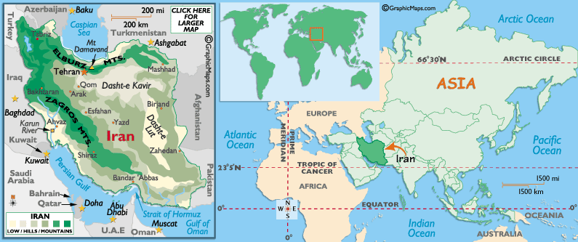

Visa: The visa has to be obtained prior to arrival in the country.

Flights:
Iran Air flies to Tehran from Mumbai twice week, on Tuesday and Fridays.

Capital City:
Tehran
Major Cities:
Karaj, Mashhad, Isfahan, Shiraz and Tabriz

Currency:
Iranian Rial (IRR)
Official Language:
Persian (Farsi)
Time Zone:
1.5 hrs behind India
International Calling Code:
+98

Getting Around
The two main ways of getting around in cities of Iran are taxies and buses. In Tehran subway is also a good substitute for many routs. It has got 3 lines (and 2 planning) with 28 stations. It is also one of the most punctual organizations in Iran. It operates from 6:00 - 22:00h with a detailed schedule.
Taxis: One of the easiest ways of getting around in Iran especially in Tehran is by taxi. You only need to hail one. There are two kinds of taxis: shared or private. Shared taxis are mostly yellow or orange. If you wish the driver not to pick up any passenger and take you directly to your destination, specify to travel "Darbast", otherwise he would go his route and pick up passengers. You can also call taxi agencies or ask your hotel to arrange that for you.
Buses: If you choose to get around in an inexpensive way you can use bus. Most large town and cities have good local bus services. Women and men are separated in the buses; women have to sit at the back and it will be very difficult if you are traveling as a couple and need to discuss where to get off.
Train: To travel between cities there are 2 more options, you can go by train and air. Train routes are limited to the major cities and a train journey will take longer than traveling by the coach. But train tickets are often cheaper, they are more comfortable and their Sleeper berths at nights allow you having a good sleep while saving on time and a night's accommodation.
Flights: Since Iran is a huge country, air services are a blessing. Airlines such as Iran air, Iran Aseman, Mahan, Kish air, and others provide an extensive network of flights to all provincial capitals and places of interest for travelers. The only problem can be availability; you need to book your ticket in advance.

Clothing
Iran has a dress code which all travellers and residents are expected to follow upon their arrival and/or during their stay in the country. The rules are quite simple: men are assumed not to wear short trousers and earrings in public, as well, women are required to wear scarf when in public.

MUST SEES:

TEHRAN
In Tehran there is a wide range of good museums. Strongly recommended would be the National Museum of Iran, also known as the Archaeological Museum of Iran (next door to which is the Islamic Arts Museum), the Carpet Museum and the National Jewels Museum.
A trip to Darband in the north of Tehran, nestling at the foot of Mount Tochal, can provide a welcome break from the hustle and bustle of the city. A pleasant trail lined with cafes, kebabis and what is said to be the longest telecabin in the world, makes a refreshing excursion.
A day trip into the Alborz Mountains - hiring a taxi and then walking is highly recommended.

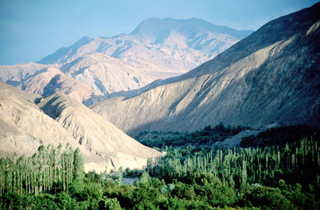
There is little in the way of organised night life. Iranian classical and traditional music is performed in centres such as Rudaki Hall.

Grand Bazaar of Tehran
It is believed that parts of today's bazaar predate the growth of the village of Tehran under the Safavids' dynasty, although it was during and after this period that the bazaar began to grow gradually.
Today, the Grand Bazaar of Tehran is the largest world's bazaar. It includes 10km of covered stores and has got several entrances, some of which are locked and guarded at night. The bazaar is a city within a city, encompassing more than a dozen mosques, several guesthouses, a handful of banks, one church and even a fire station. Each corridor specializes in a particular commodity: copper, paper, gold, spices and carpet.
SHIRAZ
SHIRAZ is the capital of Fars province and has a population of about 1.5 million. The city dates from Achaemenid times and lies in a pleasant green valley surrounded by mountains. The relatively high altitude (1600m) ensures a temperate and pleasant climate throughout most of the year.
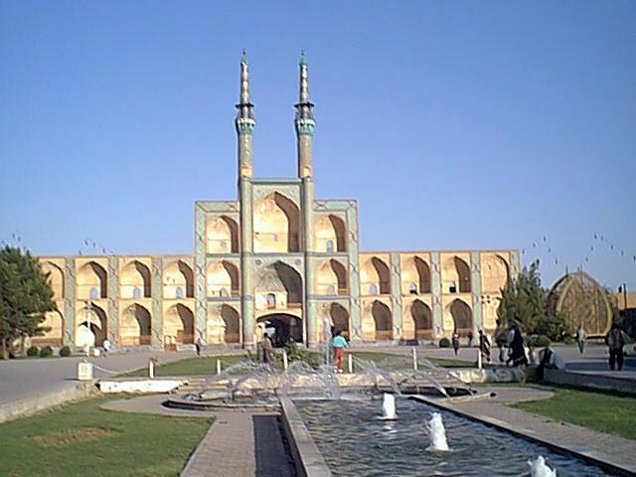
Shiraz is a relaxed city, long synonymous with poetry and learning, gardens, roses and nightingales. It was one of the most important cities in the medieval Islamic world and was the Iranian capital during the Zand dynasty (1747-79), when many of its most attractive buildings, such as the vaulted bazaar, were constructed.
Places to visit include the tombs and gardens of celebrated poet Hafez, where you can while away the hours in the enchanting teahouse, the Shah-Cheragh shrine and museum, the colourful Bazaar-e Vakil and the adjoining Vakil mosque, the Bagh-e Eram, a famous Persian garden, built in the 19th century and the Koran Gate on the outskirts of the city. For a memorable traditional Persian meal, visit the Hammam-e Vakil restaurant in the restored city baths.

Persepolis
The surviving ruins of Persepolis today are a mere shadow of Persepolis' former glory. It was founded by Darius I in 518 BC and was added to by the subsequent kings over a period of about 150 years. In its heyday the city spread over an area of about 125000 sq meters and was the place where all the people of the empire came over No Ruz (New Year) to pay homage to the kings.
The complex holds in Ceremonial palaces, Halls, small dedicated palaces, royal treasury and tombs. Today this monument consists of the remains of several monumental buildings such as Gate of All Nations, Palace of 100 Columns, Palace of Darius, Xerxes’ Palace, Central Palace, and Apadana Palace. Persepolis was burned to the ground by Alexander in 330 BC.

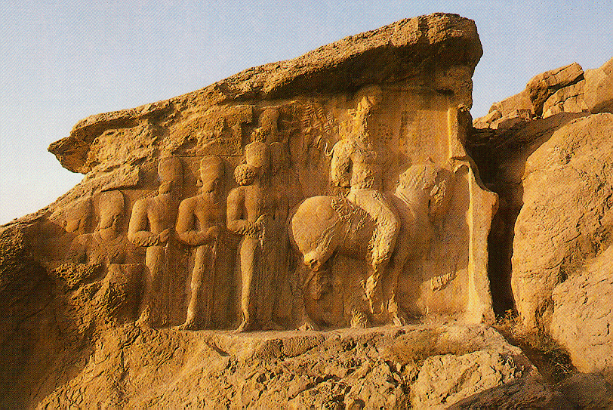
A short distance from Persepolis, at Nagsh-e Rostam, the tombs of four Achaemenian kings, including Darius I, are cut into the cliff face.
Slightly further afield at Pasargadae (48km north-east of Persepolis) lies the tomb of Cyrus the Great.
ESFAHAN
ESFAHAN is perhaps Iran’s most visually stunning city, and contains some of the country’s most memorable attractions. The city is about 400km south of Tehran and dates from 5 BC, when it was the summer residence of Achaemenian kings. It became the legendary capital of the Safavids in the 17th century, when most of the spectacular buildings still visible today were constructed.
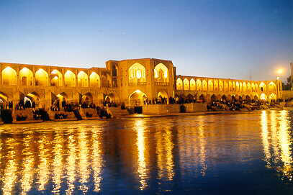
There are dozens of interesting places to visit, many of which are located within the spectacular Emam Square, originally constructed as a polo ground in 1612. The square boasts the Emam Mosque, a stunning building decorated entirely in rich blue-tiled mosaic designs, the beautiful Sheikh Lotfallah mosque, the Ali Qapu palace and the enormous bazaar, which has 5km of narrow pathways to explore.
Other sites in Esfahan include the Chehel Sotun Museum, a 17th century pavilion set in pleasant gardens and the Armenian Vank Cathedral. You should also stroll down to the river to catch a glimpse of Esfahan’s famous bridges, and perhaps stop for refreshment at one of the many teahouses.

Siosepol Bridge in Isfahan
Siosepol or Allah Verdi Khan is one of the eleven and the most famous bridges of Isfahan. It is highly ranked as being one of the most famous examples of Safavid bridge design. Allah Verdi Khan Bridge, that is one of the spectacular masterpieces of King Abbas's royalty, has been built in early 17th century under supervision and fund of his famous commander Allah Verdi Khan. It is about 300m long and 14m wide, and is the longest bridge over Zayandeh Rood River. It consists of two layers of 33 arches.
The road along the top is sandwiched between high walls which give some shelter from the wind as well as protection for travelers who can walk along the footpaths on either side to avoid the crush of the traffic. The southern side of the bridge, where the waters of the Zayandeh run more swiftly has supplementary arches, and it is this that makes them suitable as a tea house.
This historical bridge is one of the architectural and bridge-making feats in Iran which has a unique aesthetics and magnificence. It is very attractive and good for walking. Try to go for a walk at night. It has a marvelous view.

The Grand Bazar of Isfahan
The Bazaar of Isfahan, the heritage of the Saljuqid and Safavid era is one of the oldest and largest bazaars of the Middle East. It stretches between Imam Sq and the Jameh Mosque several kilometers away. The bazaar can be entered at dozens of points along its winding route, but the main entrance is via the Qeysarieh Portal at the northern end of Imam Sq. the high gateway is decorated with tiles and, higher up, frescoes by great Reza Abbasi, depicting Shah Abbas's war with the Uzbeks.
Like most Iranian bazaars, Bazaar-e Bozorg is loosely divided into several interconnected corridors, each specializing in a particular trade or product, with carpet dealers, goldsmiths, samovar-makers, shoe makers, dyers, all having their own quarters. You can also find several mosques, tea shops, bathhouses, and even gardens. Small apertures in the vaulted roof let in sufficient light yet kept out the intense heat of summer and retained warmth in winter.

Kandovan village and its rocky hotel
The beautiful and historical Kandovan village is located 22 km from the city of Osco and 62 km from city of Tabriz. The pyramid-shaped houses of the village have a rocky architecture. Due to some researches, its history dates back to the seventh hegira century, some surveys indicate that the village has a record of pre-Islamic era. These houses are still being inhabited.
Kandovan village also has a scenic beauty. It's a popular resort and there are hotels and restaurants there to serve tourists. Its mineral water is also popular by visitors and is believed to be a cure for kidney disease. The unique characteristics of Kandovan along with its magnificent nature provide amusing place to relaxation and has enjoyable time.

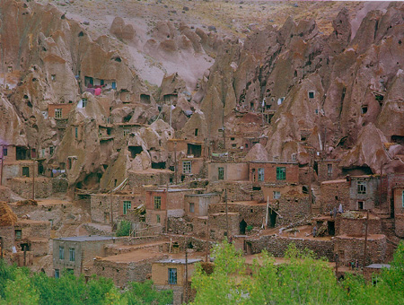
Kandovan Tourism Cliff (Rocky) Hotel (5 star), located at the heart of the village. It is the first of its kind in Iran and the second in the world after Turkey's rocky hotel.

Takht-e Soleyman
"Solomon's Throne", as the translation of the Persian designation suggests, is located in a valley surrounded by a volcanic mountain region in north-western Iran. It was the spiritual center of Zoroastrianism in the 3rd century AD and includes the principal Zoroastrian sanctuary. It is an outstanding example of Zoroastrian sanctuary integrated with Sassanid palatial architecture which have emphatically affected the development of the Islamic architecture.
The ensemble structure has been constructed within an oval-shaped rampart. The entrance of the place, which was made in the Mongol period, is a stone gate with Kufic inscriptions at the top, In the middle of the aggregate, there is a large stone pool built for water storage purposes. Around this pool there are the walls and remains of 38 towers and two porticoes named Ivan-e Khosrow and Ivan-e-Garabaq-e-Khosrow. A prison, a Museum, a Castle, thermal springs and streams are of other attractions of the place.

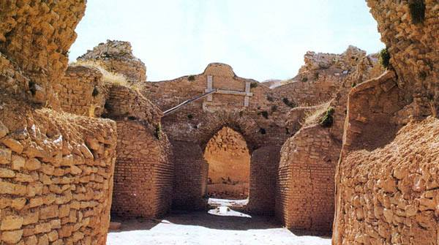

Pars Museum
The structure is an octagonal, graceful building with a spacious hall and several recesses and pavilions. It is situated in the center of a beautiful park with some pools.
The building dates back to the time of "Karim Khan Zand", when he would use it for formal meetings and for receiving foreign ambassadors. According to his own will he was buried in this same building after his death.
Being in the vicinity of the citadel of Karim Khan Zand, the building has been used as a museum since 1937. The museum houses valuable articles, such as a priceless Quran by Imam Ali, the son-in-law of the prophet plus other manuscripts of Quran, archaeological relics and finds, and pieces of pottery.There are also beautiful oil paintings showing Moses and Abraham and also tileworks depicting Solomon's enthronement.’’

Shopping
While the shops offer a wide selection of quality goods, local items can be bought in the many bazaars. Purchases include hand-carved, inlaid woodwork, saffron, pistachio nuts, carpets, rugs, silks, leather goods, mats, tablecloths, gold, silver, glass and ceramics. Bargaining is customary. There are restrictions on which items may be taken out of the country.
Shopping is exhausting and interesting. The bazaar in South Tehran is and experience in itself and is definitely worth visiting. Carpets - the range and choice is extraordinary - are an obvious buy, though it will save you money if you can go with an Iranian friend
Shopping hours
Generally 9am-1pm and 3pm-8pm

